**AUTOMATING AWS WITH PYTHON | PART 4: RDS**



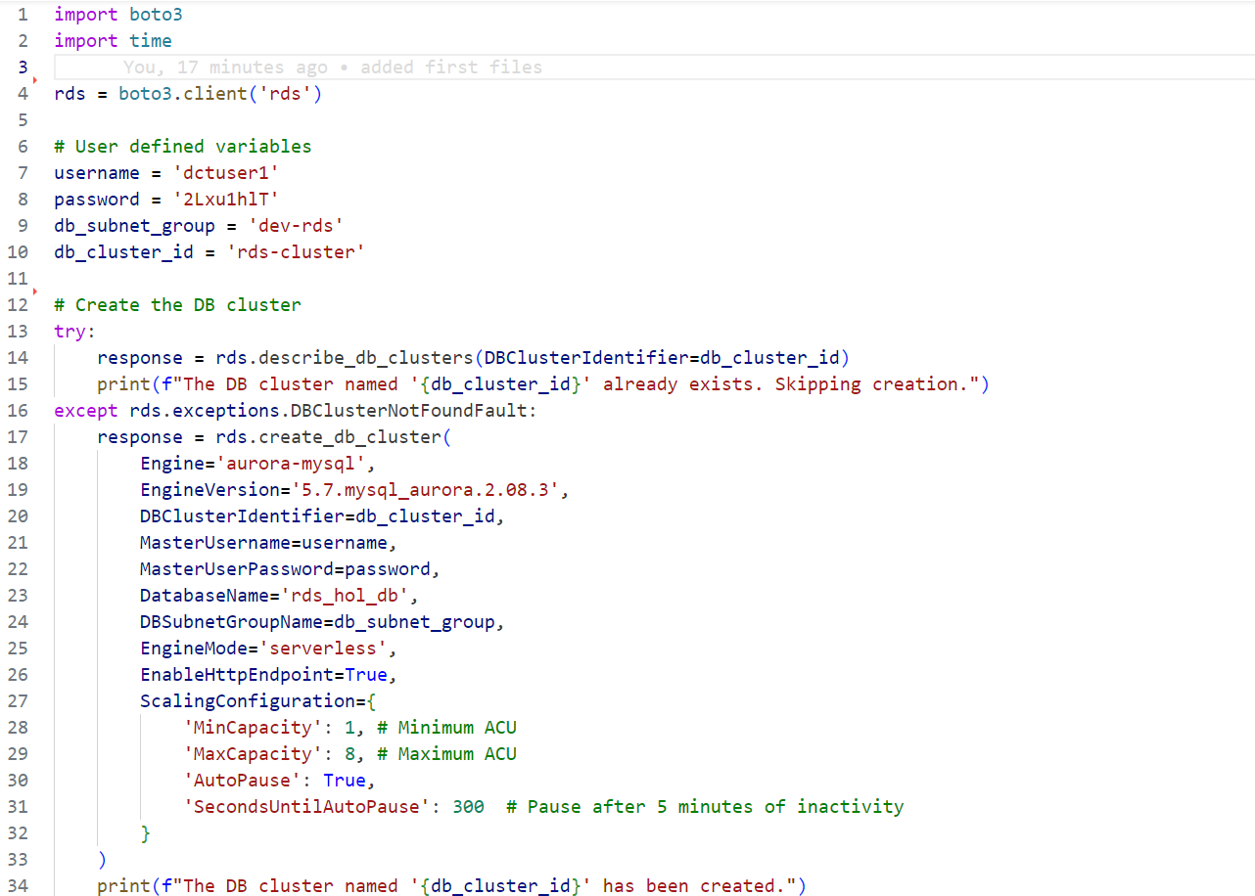

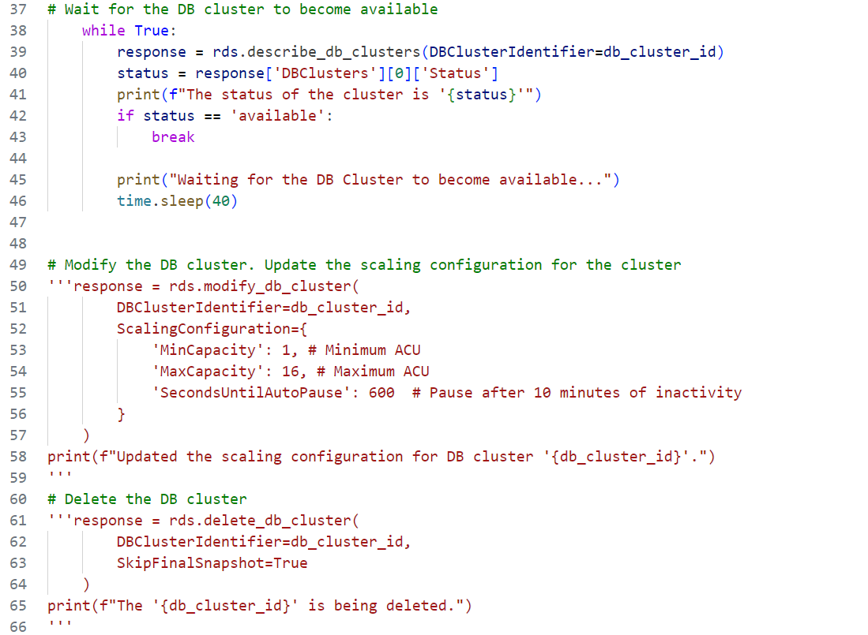

**CODE BREACKDOWN**

**1. Import Statements**

**`boto3`:** This is the AWS SDK for Python that allows interaction with AWS services, including RDS.

**`time`:** This standard Python module is used to pause execution of the script.

**2. Create RDS Client and User Variables**

**`rds = boto3.client('rds')`:** This initializes a client object to interact with the Amazon RDS service.

**`username`, `password`, `db_subnet_group`, `db_cluster_id`:** These variables store the necessary details for managing the RDS cluster, including credentials and identifiers.

**3. Check if DB Cluster Already Exists**

**`response = rds.describe_db_clusters(DBClusterIdentifier=db_cluster_id)`:** This attempts to retrieve information about the DB cluster with the given identifier.

If the cluster is found, it prints a message indicating that the cluster already exists.

If the cluster does not exist (catches **`DBClusterNotFoundFault`** exception), the script proceeds to create a new cluster.

**4. Create a New DB Cluster (If it Doesn’t Exist)**

**`rds.create_db_cluster(...)`:** This command creates a new Aurora MySQL DB cluster with specified parameters:

* **`Engine`:** Sets the database engine to Aurora MySQL.
* **`EngineVersion`:** Specifies the version of Aurora MySQL.
* **`DBClusterIdentifier`:** Assigns a unique identifier to the DB cluster.
* **`MasterUsername`** and **`MasterUserPassword`:** Sets the master user credentials.
* `**DatabaseName`:** Names the initial database in the cluster.
* **`DBSubnetGroupName`:** Defines the VPC subnet group for the cluster.
* **`EngineMode`:** Sets the cluster to serverless mode.
* **`EnableHttpEndpoint`:** Allows HTTP access to the cluster.
* **`ScalingConfiguration`:** Configures automatic scaling and auto-pause settings.

Prints a confirmation message indicating that the cluster has been created.

**5. Wait for DB Cluster to Become Available**

The script continuously checks the status of the DB cluster using **`rds.describe_db_clusters`.**

It retrieves and prints the cluster status every 40 seconds until the status becomes **`'available'**`, indicating that the cluster is ready for use.

**6. (Commented Out) Modify DB Cluster**

This section, if uncommented, would update the scaling configuration of the existing DB cluster:

Adjusts the maximum capacity and changes the auto-pause timing.

**7. (Commented Out) Delete DB Cluster**

This section, if uncommented, would delete the DB cluster:

**`SkipFinalSnapshot=True`** specifies that no final snapshot of the database should be created before deletion.

**Summary**

* The script first checks if a specified Aurora MySQL DB cluster exists. If not, it creates a new cluster with the given configurations.
* It then waits for the cluster to become available before proceeding.
* There are also commented-out sections that provide functionality for modifying or deleting the DB cluster if needed.